EPITOME MODEL ISLAMIC SCHOOLS
2ND TERM EXAMINATION FOR
SENIOR SECONDARY SECTION
2024/2025 ACADEMIC SESSION
BIOLOGY

Name: | Class: Year 11(S.S.S 2) | Time Allowed: 2hours
FOR MARKERS ONLY
Sections in Paper | Scores Obtainable | Scores Obtained
Section A (Objectives)
Section B (Theory)
Total Scores
Do not start until you are told to do so

SECTION A – ANSWER ALL QUESTIONS
- One of these will not allow osmosis to take place
(a)Cellophane (b)Transparent
(c)Cow’s bladder (d)Pig’s bladder

- Bones are connected to bones by the means of
(a)synovial cavity (b)tendons
(c)ligaments (d)synovial fluid

- Pairing is a common reproductive behavior of the following except
(a)man (b)toads
(c)winged termites (d)none of the above

- If an isolated cell is left in distilled water for two hours, it is likely to
(a)lose some of its water to the surrounding water
(b)lose all of its water to the surrounding water
(c)become more turgid
(d)die due to excess water

- Movement in animals is achieved as a result of
(a)contraction and relaxation of muscles
(b)synovial fluid streaming
(c)contraction of ligaments
(d)relaxation of tendons

Use the diagram below to answer questions 6-9
II
I
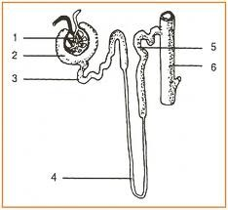
III
IV
VII
V
VIII

VI

- The structure above is called
(a)bowman’s capsule (b)glomerulus
(c)nephron (d)loop of Henle

- Urine filtration takes place in the part labelled
(a)II (b)III (c)IV (d)VI

- Selective reabsorption of essential materials takes place in the parts labelled
(a)I, II and III (b)III, IV and V
(c)V, VI and VII (d)VII, IV and I

- The part labelled IV is called
(a)loop of Henle
(b)bowman’s capsule
(c)proximal convolated tubule
(d)distal convoluted tubula

- Which of the following structures transport water from the roots to the leaves?
(a)Phloem (b)Xylem (c)Cambium (d)Cortex

- Which of the organisms respires through the body surface?
(a)Tridax (b)Man (c)Amoeba (d)Hibiscus

- The stomata of a leaf performs the same function as
(a)trachea of toads (b)pharynx of man
(c)spiracles of insects (d)scales of fish

- One of these is associated with respiration in insects
(a)Spiracle (b)Lungs (c)Gills (d)Air sac

- One of these group of bones is equivalent to the metatarsals of the hind limb
(a)Carpals (b)Metacarpals (c)Phalanges (d)Tarsals

- Filtered blood from the kidney is carried back to the circulatory system through the
(a)renal artery (b)renal vein
(c)vena cava (d)pulmonary vein

- One of these vitamins aids blood clotting
(a)Vitamin B (b)Vitamin C
(c)Vitamin K (d)Vitamin E

- Which of the following is not the function of the kidney?
(a)Production of urine (b)Production of bile
(c)Removal of urea (d)Osmoregulation

- Which of the following organs deals with detoxification?
(a)Lungs (b)Kidney (c)Liver (d)Gall bladder

- Pancreatic duct opens into the
(a)caecum (b)duodenum (c)ileum (d)colon

- Root hairs absorb water from the soil through
(a)diffusion (b)osmosis
(c)translocation (d)plasmolysis

- Turgo pressure occurs in a cell when the
(a)cell loses water to it environment
(b)cell is put in an isotonic solution
(c)volume of the cell decreases
(d)volume of its cell sap increases

- One of these reduces friction between bones in a joint
(a)Serum (b)Tissue (c)Lymph (d)Synovial fluid

- Which of the following organs in mammals is responsible for the removal of excess water?
(a)Spleen (b)Kidney (c)Liver (d)Large intestine

- Hydra is able to perform all of the following except
(a)feeding (b)movement
(c)photosynthesis (d)digestion

- One of these exhibits extracellular digestion
(a)Mould (b)Green plants
(c)Algae (d)Bryophytes

- Which of the following substances is a common excretory product to both plants and animals?
(a)Urine (b)CO₂ (c)O₂ (d)Mineral salts

- Which of the following structures in human body provides the best surface for diffusion?
(a)Skin (b)Stomach
(c)Alveolus (d)Oesophagus

- Largest quantity of water is removes through the
(a)skin (b)kidney
(c)lungs (d)large intestine

- The major function of xylem tissues is
(a)translocation of manufacture food
(b)transportation of water and minerals from roots to other parts
(c)storage of manufactured food
(d)transpiration of excess water from the plant to the environment

- Green plants lose water to the atmosphere through the process called
(a)respiration (b)photosynthesis
(c)translocation (d)transpiration

- One of these occupies the canal of the vertebral column
(a)Cerebrum (b)Cerebellum
(c)spinal cord (d)Medulla oblongata

- Transpiration takes place in
(a)mesophyll cells only (b)roots only
(c)all living cells (d)stomata and lenticels only

- All of these perform excretory function except
(a)liver (b)kidney (c)lungs (d)pancreas

- None provides articulating surfaces for ribs except
(a)lumber (b)thoracic (c)cervical (d)sacral

- All trees in a forest would be an example of
(a)community (b)ecosystem
(c)population (d)organism

- Fungi and algae were both placed under the same division thallophyta because
(a)both are autotroph
(b)both are saprotroph
(c)both do not have a body that is differentiated into roots, stems and leaves
(d)both have false leaves

- Glomerular filtrate contains the following except
(a)water (b)urea (c)blood corpuscles (d)glucose

- Which of these is a direct photosynthetic product?
(a)Starch (b)Glucose (c)Protein (d)Fats

- Which of the following is not an excretory product?
(a)Urine (b)Sweat (c)Faeces (d)Salts
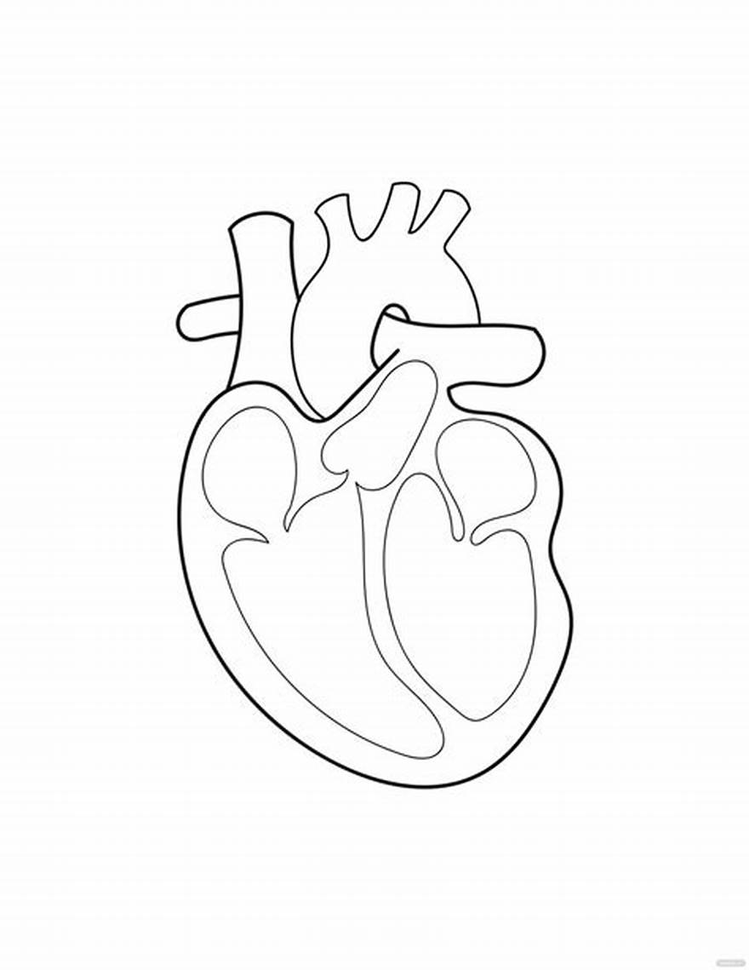
II
I

III
IV

V
VI

Use the diagram above to answer questions 40-42

- Why is the wall of the part labelled V thicker than VI/
(a)V is left ventricle and VI is right ventricle
(b)VI is the left ventricle and V is the right ventricle
(c)V receives blood from the left auricle and VI from the right auricle
(d)V pumps blood with high pressure round the body and VI pumps blood only into the lungs

- The part labelled III is called
(a)left ventricle (b)left auricle
(c)right ventricle (d)right auricle

- Pulmonary artery is labelled
(a)I (b)II (c)IV (d)III

- One of these is a strong wall that separates the heart into two halves
(a)Tricuspid valve (b)Bicuspid valve
(c)Septum (d)Vena cava

- One of the following hind limb bones is equivalent to the humerus of the forelimb
(a)Femur (b)Fibula (c)Patella (d)Tibia

- One of these is not an excretory product of plants
(a)Sweats (b)Tanin (c)Gum (d)Alkaloids

- The joint between atlas and axis vertebrae allows
(a)rotary movement only
(b)up and down or nodding movement only
(c)rotary and nodding movements
(d)no movement at all

- In animals, cilia, flagella, pseudopodia and chaetae can be used for
(a)reproduction (b)fighting enemies
(c)attachment to plants (d)locomotion

- Which of the following animals is cold-blooded?
(a)Cat (b)Lizard (c)Whale (d)Horse

- One of these insects has an incomplete metamorphosis
(a)Butterfly (b)Bee
(c)Grasshopper (d)Mosquito

- The deficiency of vitamin D leads to
(a)scurvy (b)beri-beri (c)rickets (d)pellagra

SECTION B – ANSWER THREE QUESTIONS
- a. Define skeleton (2mks)
b. Explain three types of skeleton (3mks)
c. Outline four functions of mammalian skeleton (2mks)
d. Outline three bones of appendicular skeleton (3mks)

- a. Explain the term supporting tissues (2mks)
b. Name four plant supporting tissues with a function each (4mks)
c. Describe two features of a typical vertebra (4mks)

- a. Draw and label fully the structure of a
mammalian kidney (6mks)
b. List two excretory organs and two excretory products of mammals (4mks)

- a. Outline five organism and their excretory
organs in each case (5mks)
b. Using the knowledge of osmosis explain the opening and closing of stomata in plants (5mks)

- a. List four types of joints(4mks)
b. With the aid of a diagram explain urine formation and removal (6mks)

